Choose the letter of the correct answer. In all cases, NOTA means “none of these answers”.
1) Solve : 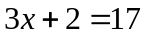
A) 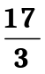 B) 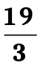 C) 5 D) 7 E) NOTA
2) Sour Kangaroo’s pouch is 10 by 10 by 10 feet. If each little roo is 10 ft³, how many little roos can fit in Sour Kangaroo’s pouch?
A) 10 B) 100 C) 1000 D) 10000 E) NOTA
3) Horton’s trunk is 12 feet long! Assuming he fills it at 16 feet/sec, how many seconds will it take to fill his whole trunk?
A) 0.75 B) 1.25 C) 28 D) 192 E) NOTA
4) Simplify, assuming 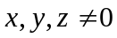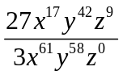
A) 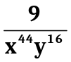 B) 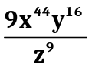 C) 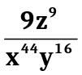 D) undefined E) NOTA
5) The base of Mount Nool is located at (2, 8) and the top of Mount Nool is located at (42, 1920). What is the slope of the Mountain?
A) 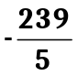 B) 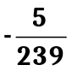 C) 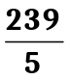 D) 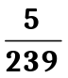 E) NOTA
6) Simplify
A) 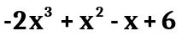 B) 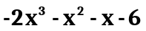 C) 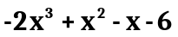
D) 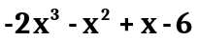 E) NOTA
7) Horton is bathing in the jungle of Nool, in the heat of the day in the cool of the pool, when one day he finds the pool quite cool, so he takes out his thermometer, his trusty tool. He measures it to be 50 degrees Fahrenheit, that’s too cool for Nool! But in Celsius that cool isn’t so cruel, so he found out it’s how cool in Celsius? (The formula for conversion is 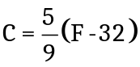, where C is the degree in Celsius and F is the degree in Fahrenheit.)
A) 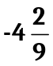° B) 2° C) 10° D) 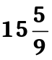° E) NOTA

8) Simplify 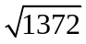
A) 14 B) 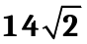 C) 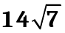 D) 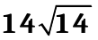 E) NOTA
9) Solve for x:
A) 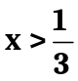 B) 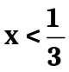 C) x > 5 D) x < 5 E) NOTA
10) What is 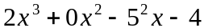 if 2x - 3 • 6 = 23 - 5 • 9 ?
A) -46 B) -2 C) 0 D) 30 E) NOTA
11) In the Jungle of Nool, the ratio of swamps to lakes is 7:4. If there are 132 lakes and swamps in the Jungle of Nool, how many swamps are there?
A) 11 B) 12 C) 77 D) 84 E) NOTA
12) If 3x + y = 15 and 7x + 2y = 34, what is x - y?
A) -1 B) 1 C) 4 D) 7 E) NOTA
13) Expand : (101x + 12)(4x + 3)
A) 404x² + 36 B) 404x² + 255x + 36 C) 404x² + 303x + 36 D) 404x² + 351x +36 E) NOTA
14) One day Horton falls off a cliff. Vlad will try to rescue him. Horton gets a 10 second head start and falls at 10 meters per second. The cliff is 260 meters high. At least how fast (in meters per second) does Vlad have to fall in order to catch Horton before Horton hits the boiling peanut oil on the ground?
A) 10 B) 10.4 C) 16.25 D) 26 E) NOTA

15) A rectangular pool has sides of x - 1 and x - 3, and a sidewalk around it with edges of width 2 units. The sidewalk is 32 square units in area. What is x? Note: Figure is not to scale
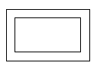
A) 2 B) 4 C) 6 D) 8 E) NOTA

16) Solution x is 15% salt. Solution y is 30% salt. What percentage salt is a solution which is made up of 5 gallons of pure water, 2 gallons of solution x, and 3 gallons of solution y?
A) 0% B) 12% C) 22.5% D) 24% E) NOTA
17) Morton is 6 feet shorter than Horton, and Mount Nool is 4 times as tallas Horton. Morton is 30 feet shorter than Mount Nool. How tall is Horton?
A) 2 feet B) 8 feet C) 16 feet D) 32 feet E) NOTA
18) Solve: and
A) x < -1 B) -1 < x < 1 C) x > 1 D) no real solutions E) NOTA
19) If Vlad flies along the line 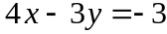 while another bird flies along the line 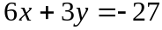, at what point do their paths cross?
A) (-3, -3) B) (3, 5) C) (12, 17) D) (30, 41) E) NOTA
20) The symbols for the operations +, -, x, and ÷ are each replaced by a different symbol from ,♠,◻,♣, though not necessarily in that order. For all real numbers a, b, and c, ab=ba and a◻(b♣c)=(a◻b) ♣(a◻c). Using correct order of operations, evaluate 12◻3♣4♠5.
A) 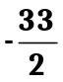 B)  C) 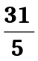 D) 9 E) NOTA
21) If 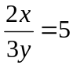, what is 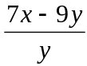?
A) -4 B) -2 C) 26 D) 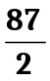 E) NOTA
22) If a² + 2ab + b² = 64 and a and b are positive integers, what is the sum of a and b?
A) 3 B) 5 C) 8 D) 64 E) NOTA
23) The mayor and Jojo are 24 miles apart and running towards each other, the mayor at 16 miles per hour and Jojo at 8 miles per hour. Interestingly, a fly started to fly from the mayor to Jojo and back again the moment the mayor and Jojo began to run towards one another. The fly continues this pattern until the mayor and Jojo meet. How many miles will the fly travel before the mayor and Jojo meet each other?
A) 1 B) 12 C) 24 D) 48 E) NOTA

24) Write in scientific notation : (2.1 x 10⁸)(4 x 10⁻¹¹)
A) 8.4 x 10³ B) 8.4 x 10⁻³ C) 8.4 x 10⁻⁸⁸ D) 8.4 x 100⁻³ E. NOTA
25) The Fibonacci sequence is as follows: 1, 1, 2, 3, 5, 8, 13, 21, 34, 55, 89… If 89 is the 11th term, find the 15th term.
A) 144 B) 233 C) 377 D) 610 E) NOTA
26) What is 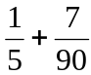 in decimal notation?
A) 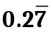 B) 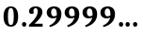 C) 0.29 D) 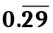 E. NOTA
27) If 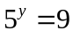, what is 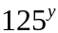?
A) 27 B) 54 C) 225 D) 729 E) NOTA
28) Given that
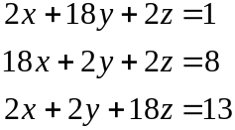
What is x + y + z?
A) 0 B) 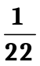 C) 1 D) 22 E) NOTA
29) A function takes in a number, and performs a certain operation on it. The notation for a function is f(x). For example if f(x) = 3x + 4, then f(5) = 3(5) + 4 = 15 + 4 = 19. Given that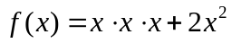, what is 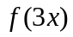?
A) 27x³ + 6x B) 27x³ + 18x C) 27x³ + 18x² D) 3x³ + 6x² E) NOTA

30) Solve. 5x - 8 = -28
A) 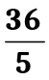 B) 4 C) -4 D) 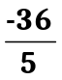 E) NOTA

